Entity Framework
- (Superset ID - 6363141) Debasish Bisoi

LAB – 1: Understanding ORM with a Retail Inventory System
Code –
Filename – Program.cs
using System;
using System.Collections.Generic;

class Program
{
static void Main()
{
var category = new Category
{
CategoryId = 1,
Name = "Electronics",
Products = new List<Product>()
};

var supplier = new Supplier
{
SupplierId = 1,
Name = "Samsung",
Products = new List<Product>()
};

var product = new Product
{
ProductId = 1,
Name = "Smart TV",
Quantity = 10,
Category = category,
CategoryId = category.CategoryId,
Supplier = supplier,
SupplierId = supplier.SupplierId
};

category.Products.Add(product);
supplier.Products.Add(product);

Console.WriteLine($"Product: {product.Name}, Category: {product.Category.Name}, Supplier: {product.Supplier.Name}");
}
}

Output –
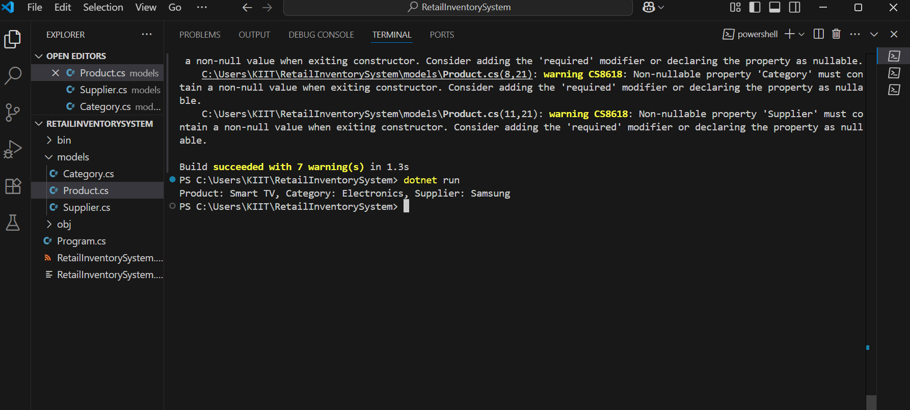

LAB – 2: Setting Up the Database Context for a Retail Store
Code –
Filename – AppDbContext.cs
using Microsoft.EntityFrameworkCore;

public class AppDbContext : DbContext
{
public DbSet<Product> Products { get; set; }
public DbSet<Category> Categories { get; set; }
public DbSet<Supplier> Suppliers { get; set; }

protected override void OnConfiguring(DbContextOptionsBuilder optionsBuilder)
{

optionsBuilder.UseSqlite("Data Source=retail.db");
}

protected override void OnModelCreating(ModelBuilder modelBuilder)
{

modelBuilder.Entity<Category>()
.HasMany(c => c.Products)
.WithOne(p => p.Category)
.HasForeignKey(p => p.CategoryId);

modelBuilder.Entity<Supplier>()
.HasMany(s => s.Products)
.WithOne(p => p.Supplier)
.HasForeignKey(p => p.SupplierId);
}
}

Output -
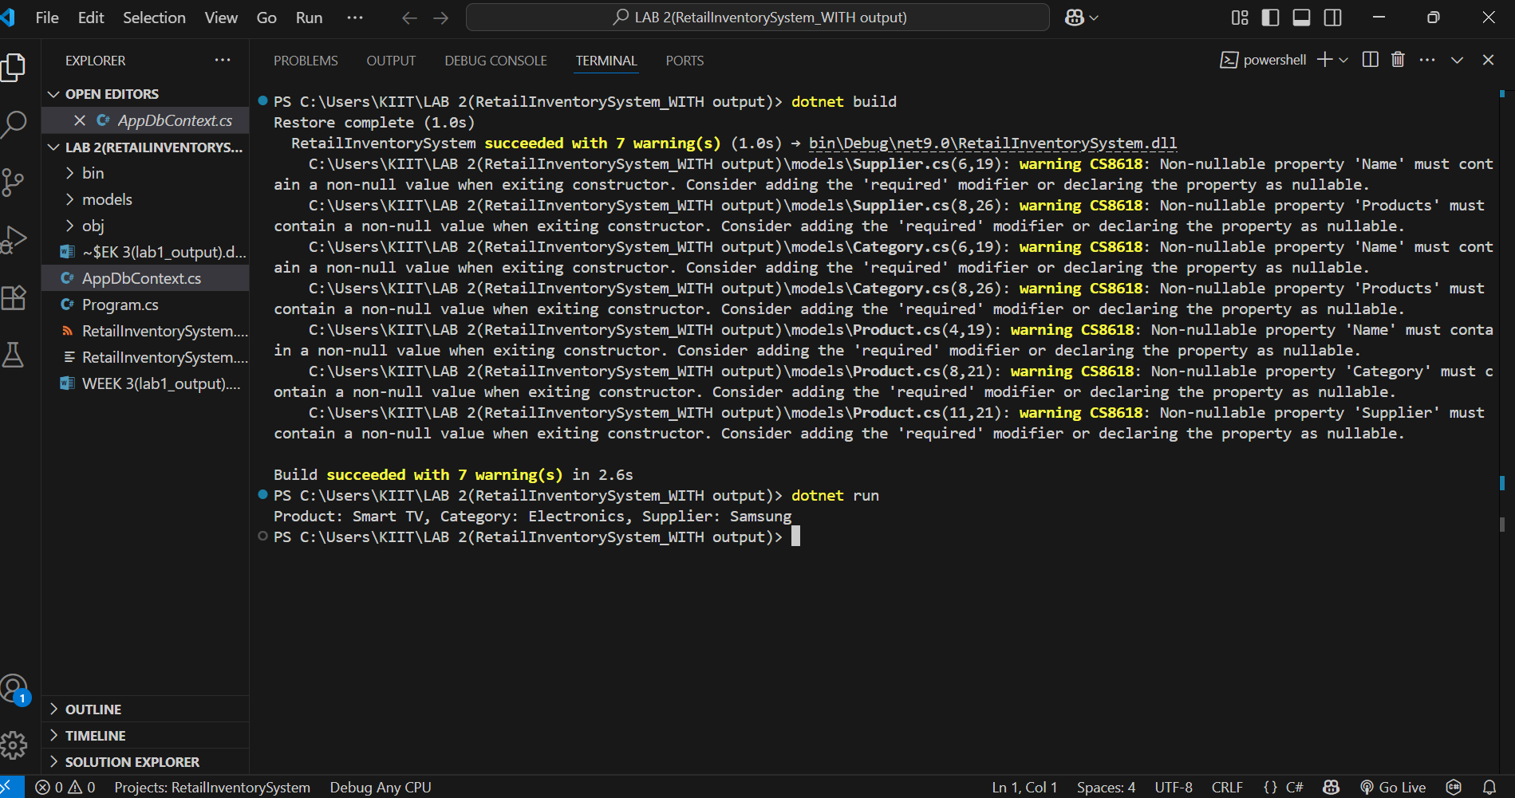
LAB – 3: Using EF Core CLI to create and apply Migrations
Code –
Under Migrations :
Filename – initialCreate.cs
using Microsoft.EntityFrameworkCore.Migrations;

#nullable disable

namespace RetailInventorySystem.Migrations
{
/// <inheritdoc />
public partial class InitialCreate : Migration
{
/// <inheritdoc />
protected override void Up(MigrationBuilder migrationBuilder)
{
migrationBuilder.CreateTable(
name: "Categories",
columns: table => new
{
CategoryId = table.Column<int>(type: "INTEGER", nullable: false)
.Annotation("Sqlite:Autoincrement", true),
Name = table.Column<string>(type: "TEXT", nullable: false)
},
constraints: table =>
{
table.PrimaryKey("PK_Categories", x => x.CategoryId);
});

migrationBuilder.CreateTable(
name: "Suppliers",
columns: table => new
{
SupplierId = table.Column<int>(type: "INTEGER", nullable: false)
.Annotation("Sqlite:Autoincrement", true),
Name = table.Column<string>(type: "TEXT", nullable: false)
},
constraints: table =>
{
table.PrimaryKey("PK_Suppliers", x => x.SupplierId);
});

migrationBuilder.CreateTable(
name: "Products",
columns: table => new
{
ProductId = table.Column<int>(type: "INTEGER", nullable: false)
.Annotation("Sqlite:Autoincrement", true),
Name = table.Column<string>(type: "TEXT", nullable: false),
Quantity = table.Column<int>(type: "INTEGER", nullable: false),
CategoryId = table.Column<int>(type: "INTEGER", nullable: false),
SupplierId = table.Column<int>(type: "INTEGER", nullable: false)
},
constraints: table =>
{
table.PrimaryKey("PK_Products", x => x.ProductId);
table.ForeignKey(
name: "FK_Products_Categories_CategoryId",
column: x => x.CategoryId,
principalTable: "Categories",
principalColumn: "CategoryId",
onDelete: ReferentialAction.Cascade);
table.ForeignKey(
name: "FK_Products_Suppliers_SupplierId",
column: x => x.SupplierId,
principalTable: "Suppliers",
principalColumn: "SupplierId",
onDelete: ReferentialAction.Cascade);
});

migrationBuilder.CreateIndex(
name: "IX_Products_CategoryId",
table: "Products",
column: "CategoryId");

migrationBuilder.CreateIndex(
name: "IX_Products_SupplierId",
table: "Products",
column: "SupplierId");
}

/// <inheritdoc />
protected override void Down(MigrationBuilder migrationBuilder)
{
migrationBuilder.DropTable(
name: "Products");

migrationBuilder.DropTable(
name: "Categories");

migrationBuilder.DropTable(
name: "Suppliers");
}
}
}

Filename – AppDbModel.cs
using Microsoft.EntityFrameworkCore;
using Microsoft.EntityFrameworkCore.Infrastructure;
using Microsoft.EntityFrameworkCore.Storage.ValueConversion;

#nullable disable

namespace RetailInventorySystem.Migrations
{
[DbContext(typeof(AppDbContext))]
partial class AppDbContextModelSnapshot : ModelSnapshot
{
protected override void BuildModel(ModelBuilder modelBuilder)
{
#pragma warning disable 612, 618
modelBuilder.HasAnnotation("ProductVersion", "9.0.6");

modelBuilder.Entity("Category", b =>
{
b.Property<int>("CategoryId")
.ValueGeneratedOnAdd()
.HasColumnType("INTEGER");

b.Property<string>("Name")
.IsRequired()
.HasColumnType("TEXT");

b.HasKey("CategoryId");

b.ToTable("Categories");
});

modelBuilder.Entity("Product", b =>
{
b.Property<int>("ProductId")
.ValueGeneratedOnAdd()
.HasColumnType("INTEGER");

b.Property<int>("CategoryId")
.HasColumnType("INTEGER");

b.Property<string>("Name")
.IsRequired()
.HasColumnType("TEXT");

b.Property<int>("Quantity")
.HasColumnType("INTEGER");

b.Property<int>("SupplierId")
.HasColumnType("INTEGER");

b.HasKey("ProductId");

b.HasIndex("CategoryId");

b.HasIndex("SupplierId");

b.ToTable("Products");
});

modelBuilder.Entity("Supplier", b =>
{
b.Property<int>("SupplierId")
.ValueGeneratedOnAdd()
.HasColumnType("INTEGER");

b.Property<string>("Name")
.IsRequired()
.HasColumnType("TEXT");

b.HasKey("SupplierId");

b.ToTable("Suppliers");
});

modelBuilder.Entity("Product", b =>
{
b.HasOne("Category", "Category")
.WithMany("Products")
.HasForeignKey("CategoryId")
.OnDelete(DeleteBehavior.Cascade)
.IsRequired();

b.HasOne("Supplier", "Supplier")
.WithMany("Products")
.HasForeignKey("SupplierId")
.OnDelete(DeleteBehavior.Cascade)
.IsRequired();

b.Navigation("Category");

b.Navigation("Supplier");
});

modelBuilder.Entity("Category", b =>
{
b.Navigation("Products");
});

modelBuilder.Entity("Supplier", b =>
{
b.Navigation("Products");
});
#pragma warning restore 612, 618
}
}
}

Output –
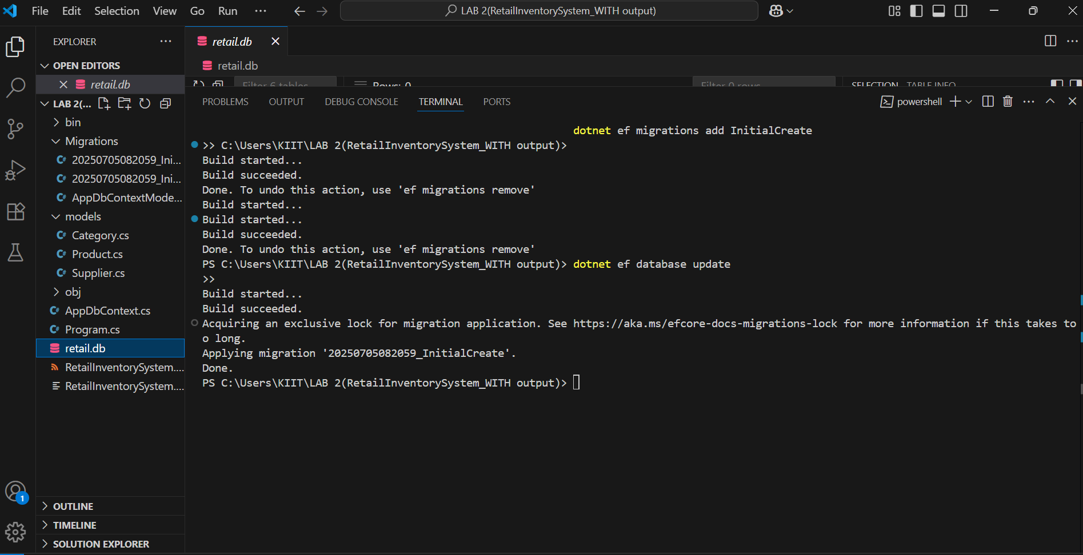
LAB – 4: Inserting initial data into the Database
Code –
Filename – Program.cs
using System;
using System.Threading.Tasks;
using RetailInventorySystem.Models;
using Microsoft.EntityFrameworkCore;

class Program
{
static async Task Main(string[] args)
{
using var context = new AppDbContext();

await context.Database.EnsureCreatedAsync();

context.Products.RemoveRange(context.Products);
context.Categories.RemoveRange(context.Categories);
await context.SaveChangesAsync();

var electronics = new Category { Name = "Electronics" };
var groceries = new Category { Name = "Groceries" };
await context.Categories.AddRangeAsync(electronics, groceries);

var laptop = new Product { Name = "Laptop", Price = 75000, Category = electronics };
var rice = new Product { Name = "Rice Bag", Price = 1200, Category = groceries };
await context.Products.AddRangeAsync(laptop, rice);

await context.SaveChangesAsync();

Console.WriteLine("Data inserted successfully!");
}
}

Output –
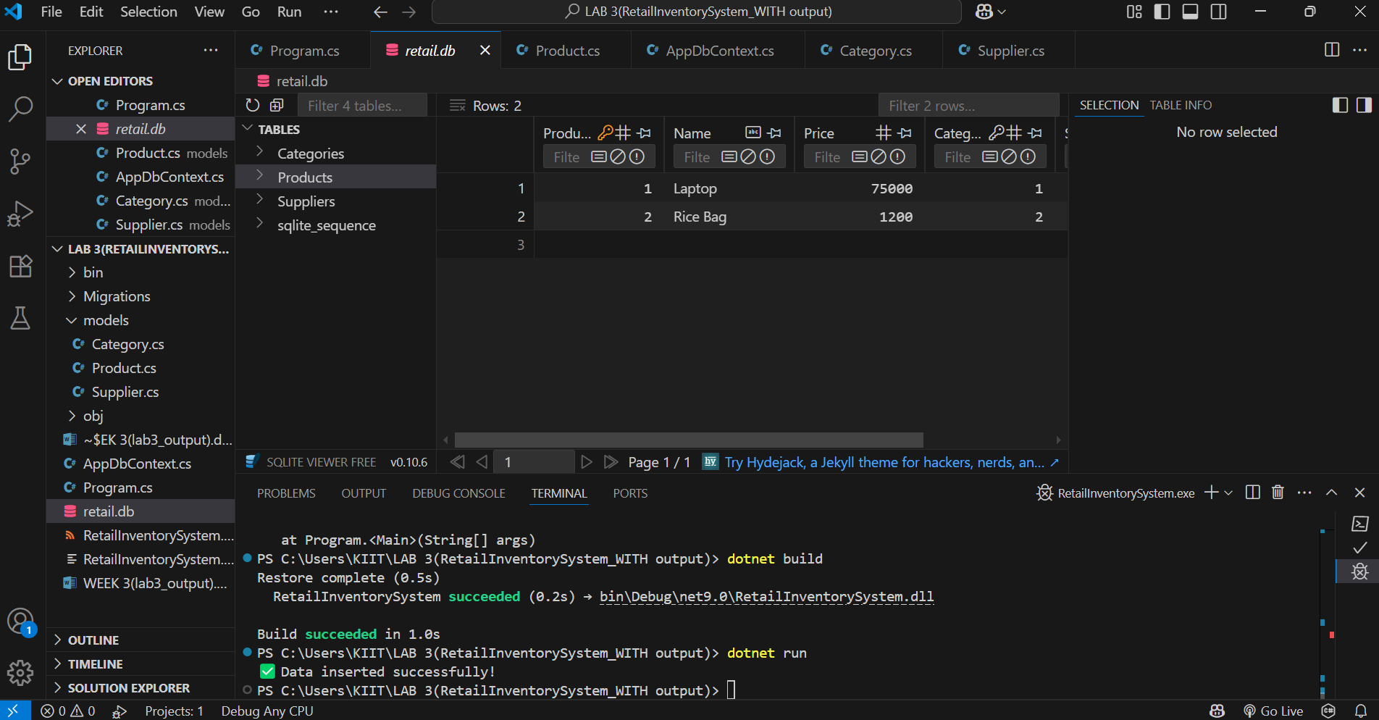

LAB – 5: Retrieving data from the Database
Code –
Filename – Program.cs
using System;
using System.Linq;
using System.Threading.Tasks;
using Microsoft.EntityFrameworkCore;
using RetailInventorySystem.Models;

class Program
{
static async Task Main(string[] args)
{
using var context = new AppDbContext();

Console.WriteLine("Products in Inventory:\n");

var products = await context.Products
.Include(p => p.Category)
.Include(p => p.Supplier)
.ToListAsync();

foreach (var product in products)
{
string categoryName = product.Category?.Name ?? "No Category";
string supplierName = product.Supplier?.Name ?? "No Supplier";

Console.WriteLine($"Product: {product.Name}");
Console.WriteLine($"Price: ₹{product.Price}");
Console.WriteLine($"Category: {categoryName}");
Console.WriteLine($"Supplier: {supplierName}");
Console.WriteLine();
}

Console.WriteLine($"Total Products: {products.Count}");
}
}

Output –
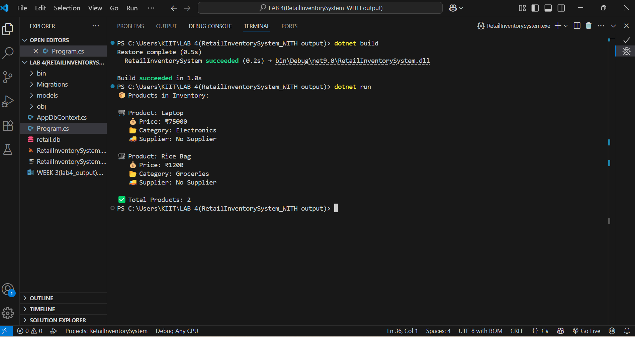

Name – Debasish Bisoi
Roll Number – 22052456
Superset ID - 6363141
College – Kalinga Institute of Industrial Technology (KIIT), Bhubaneswar

